TransSight

User Documentation

By

Devant Yadav

Gregory Stephens

Fola Alonge

Aidan Houlihan

Max Mensah

Table of Contents

Chapter 1: Installation…………………………………………………………………………………….3

1.1 How To Deploy……………………………………………………………………………….3

1.2 How To Install………………………………………………………………………………...5

Chapter 2: Feature Set……………………………………………………………………………………9

2.1 Signing Up/Logging In……………………………………………………………………….9

2.2 Home Screen……………………………………………………………………................11

2.3 Image Classification………………………………………………………………………..13

1: ***Installation***

* 1. How To Deploy

To deploy this application, simply navigate to the following Google Drive link given at the end of this documentation and share it with those you wish to use this application. This link can be shared however you wish, but make sure to inform your users that their Android smartphone is running at least Android 9.0 Pie or higher (API Level 28). Any software version lower than this and the app will not run as this was the API level it was built for. The link essentially contains the APK file that will allow the users to directly run the app on their Android smartphone, which we will go over in further detail in the next section.

Figure 1.1

Figure 1.2

* 1. How To Install

To install the TransSight app, simply open the link with your Android smartphone, a dialog box will pop up prompting you to open the app with your specified installer.

Figure 2.1

Figure 2.2

Click on your installer and the app will start downloading from the link.

Figure 2.3

You will be taken to another window verifying your installation of TransSight, tap install and the app will begin installing on to your phone.

Figure 2.4

Figure 2.5

Once the app is finished installing, the package installer will tell you the app is done installing, now you’re ready to start using TransSight!

Figure 2.6

2: ***Feature Set***

* 1. Signing Up/Logging In

When you first load up TransSight, you will be taken to a screen to register an account with TransSight, you will be prompted to enter an email and password. We will enter one into the fields as seen in figures 3.1 and 3.2.

Figure 3.1

Figure 3.2

If this is your first time using the app, TransSight will ask permission from you to gain access to the camera and your filesystem in order for the app to use its image classification system.

Figure 3.3

Figure 3.4

* 1. Home Screen

Once you’ve accepted the app’s permissions you will be taken to the home screen where you are greeted with a UI that allows you to type in any word/phrase in any language, and have the ability to select languages from a drop down menu that allow you to translate the word you just typed in to the language you just selected from the menu. Figures 3.5 to 3.7 walk you through the process.

Figure 3.5

Figure 3.6

Figure 3.7

* 1. Image Classification

If you would like to classify an image by simply pointing your smartphone’s camera at it and then translate it to one of 10 different languages, you can start this process by first tapping on the camera icon from the home screen.

Figure 3.8

This will prompt you take a picture of an object with your smartphone. When you’re satisfied with the image you have taken, tap ok and you will be taken to the image classification screen.

Figure 3.9

Figure 3.10

When you reach the image classification screen, you will see a snapshot of the image you just took, along with a button to classify the image in English as well as a dropdown menu to translate the English description into one of ten languages. Tapping “Classify!” will classify the image and translate it into English by default as seen in figure 3.11.

Figure 3.11

To change the language of the description for the object just classified, simply select one of the 10 languages from the dropdown menu, and the description will be translated into the language of your choice as seen in figures 3.12 and 3.13.

Figure 3.12

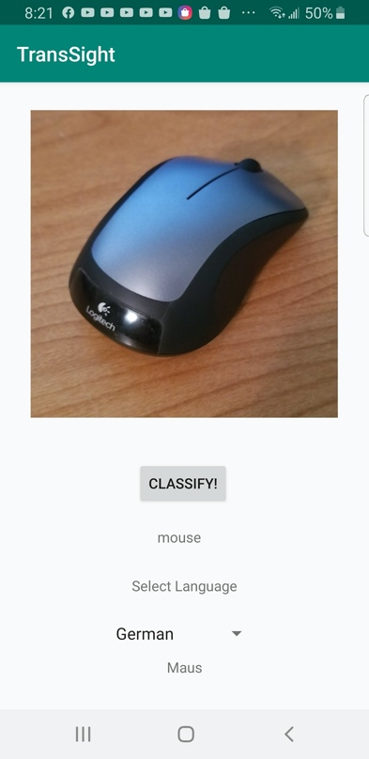

Figure 3.13

Note: Ten languages supported include English, Spanish, Chinese, French, Tagalog, Vietnamese, Korean, German, Arabic, and Russian

Google Drive Link To APK for Deployment: https://drive.google.com/file/d/10q-owPF5UyHVMu9eBvNYf51fkCjkZoRQ/view?usp=sharing